EXPERIMENT – 19
EXPERIMENT NAME
Naive Bayes Classification for Bank Loan Prediction
AIM
To implement the Naive Bayes classification algorithm in Python for predicting whether a bank loan will be approved based on the given applicant details.
APPARATUS REQUIRED
- Google Colab
- Python 3.x
ALGORITHM
- Start the program.
- Import the required Python libraries.
- Create or load the bank loan dataset.
- Preprocess the dataset.
- Separate the input features and target variable.
- Split the dataset into training and testing data.
- Create a Gaussian Naive Bayes classifier.
- Train the classifier using the training data.
- Predict the loan approval status for the test data.
- Calculate the classification accuracy.
- Display the confusion matrix and prediction results.
- Stop the program.
PROGRAM
# Experiment 19: Naive Bayes Classification for Bank Loan Prediction
# Import required libraries
import numpy as np
import pandas as pd

from sklearn.model_selection import train_test_split
from sklearn.naive_bayes import GaussianNB
from sklearn.metrics import accuracy_score, confusion_matrix
# Create sample bank loan dataset
data = {
"Income": [25000, 30000, 45000, 50000, 60000,
70000, 80000, 35000, 40000, 90000],
"Loan_Amount": [15000, 18000, 20000, 22000, 25000,
30000, 35000, 17000, 19000, 40000],
"Credit_Score": [550, 580, 650, 680, 720,
750, 780, 600, 640, 800],
"Age": [22, 25, 30, 35, 40,
45, 50, 28, 32, 55],
"Loan_Approved": [
0, 0, 1, 1, 1,
1, 1, 0, 1, 1 ]}
df = pd.DataFrame(data)

# Separate features and target
X = df[["Income", "Loan_Amount", "Credit_Score", "Age"]]
y = df["Loan_Approved"]

# Split the dataset
X_train, X_test, y_train, y_test = train_test_split(
X, y, test_size=0.2, random_state=42
)
# Create Naive Bayes classifier
model = GaussianNB()
# Train the model
model.fit(X_train, y_train)
# Predict test data
y_pred = model.predict(X_test)
# Calculate accuracy
accuracy = accuracy_score(y_test, y_pred)
print("Actual Loan Approval:")
print(y_test.values)
print("\nPredicted Loan Approval:")
print(y_pred)
print("\nAccuracy:", accuracy)
# Display confusion matrix
cm = confusion_matrix(y_test, y_pred)

print("\nConfusion Matrix:")
print(cm)
# Predict loan approval for a new applicant
new_applicant = [[55000, 22000, 700, 35]]
prediction = model.predict(new_applicant)
if prediction[0] == 1:
print("\nLoan Status: Approved")
else:
print("\nLoan Status: Not Approved")
OUTPUT
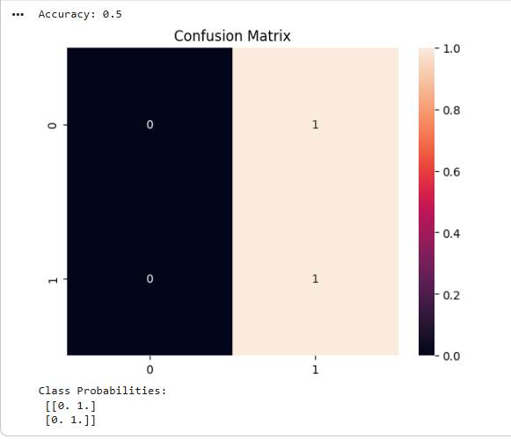
RESULT
Thus, the Naive Bayes classification algorithm for Bank Loan Prediction was successfully implemented using Python in Google Colab, and the loan prediction results were obtained.

